SAVEETHA SCHOOL OF ENGINEERING

SAVEETHA INSTITUTE OF MEDICAL AND TECHNICAL SCIENCES

ITA 0443 - STATISTICS WITH R PROGRAMMING FOR REAL TIME PROBLEM

DAY 4– LAB MANUAL Part 2

Reg No: 192110320

Name: U . Mohan drinivas

LOGISTIC REGRESSION ANALYSIS IN R

Exercise

**5. Create a logistic regression model using the “mtcars” data set with the information given**

**below.**

**The in-built data set &quot;mtcars&quot; describes different models of a car with their various**

**enginespecifications. In &quot;mtcars&quot; data set, the transmission mode (automatic or manual)**

**is describedby the column am which is a binary value (0 or 1). Create a logistic regression model**

**between the columns &quot;am&quot; and 3 other columns - hp, wt and cyl.**

SOURCE CODE:

data(mtcars)

model <- glm(am ~ hp + wt + cyl, data = mtcars, family = binomial)

summary(model)

new_data <- data.frame(hp = c(200, 300), wt = c(2.5, 3.0), cyl = c(6, 8))

predictions <- predict(model, newdata = new_data, type = "response")

OUTPUT:

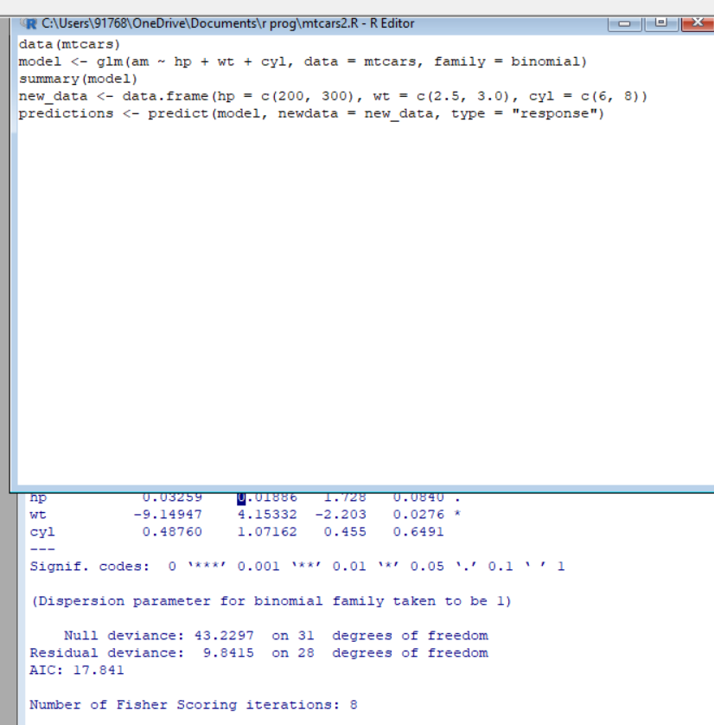

POISSON REGRESSION ANALYSIS IN R

Exercise :

6. **Create a Poisson regression model using the in-built data set “warpbreaks” with**

**information given below.**

**In-built data set &quot;warpbreaks” describes the effect of wool type (A or B) and tension (low,**

**medium or high) on the number of warp breaks per loom. Consider &quot;breaks&quot; as the response**

**variable which is a count of number of breaks. The wool &quot;type&quot; and &quot;tension&quot; are taken as**

**predictor variables.**

**SOURCE CODE:**

**data(warpbreaks)**

**head(warpbreaks)**

**str(warpbreaks)**

**summary(warpbreaks)**

**model <- glm(breaks ~ wool + tension, data = warpbreaks, family = poisson)**

**summary(model)**

**new_data <- data.frame(wool = "A", tension = "low")**

**predicted_breaks <- predict(model, newdata = new_data, type = "response")**

**OUTPUT:**

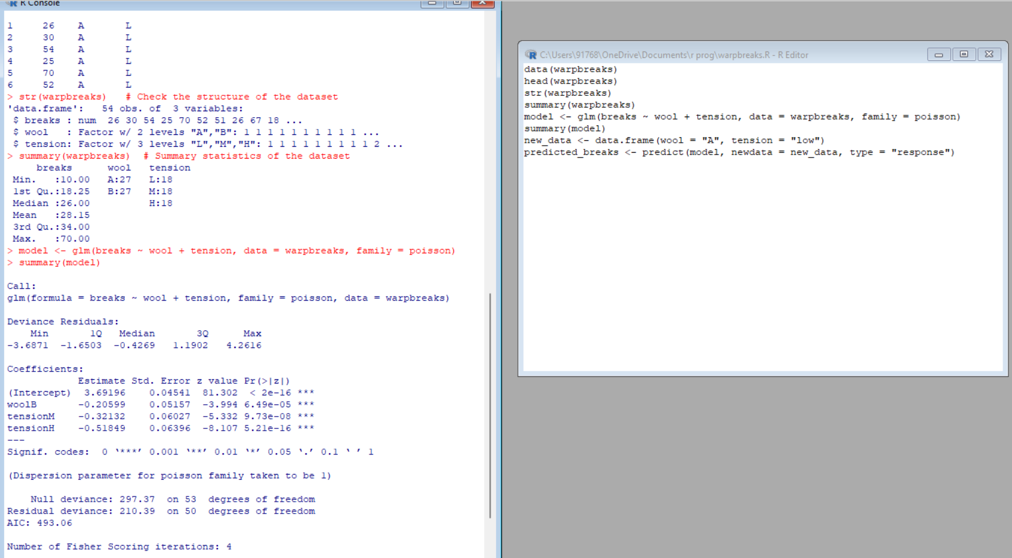

**1.Randomly Sample the iris dataset such as 80% data for training and 20% for test and**

**create Logistics regression with train data, use species as target and petals width and**

**length as feature variables , Predict the probability of the model using test data, Create**

**Confusion matrix for above test model**